Docker Engine installation in Ubuntu using convenience script

- To run the script root or sudo privileges are required. Switch from normal user to root user by running the command – sudo -i. Give the password to login.
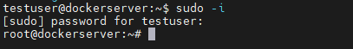
- The content of the file/script docker.sh will be available in the following URL https://get.docker.com/
- Curl the file using the command -
curl -fsSL https://test.docker.com -o test-docker.sh. Check the list availability using ls command.
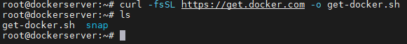
- To execute the file/script run the command sh get-docker.sh. The file/script takes care of running the apt-get update command, installing minimum pre-requisite packages, creating a repository, downloading the GPG key and then running the apt update command and finally installing the docker engine packages.
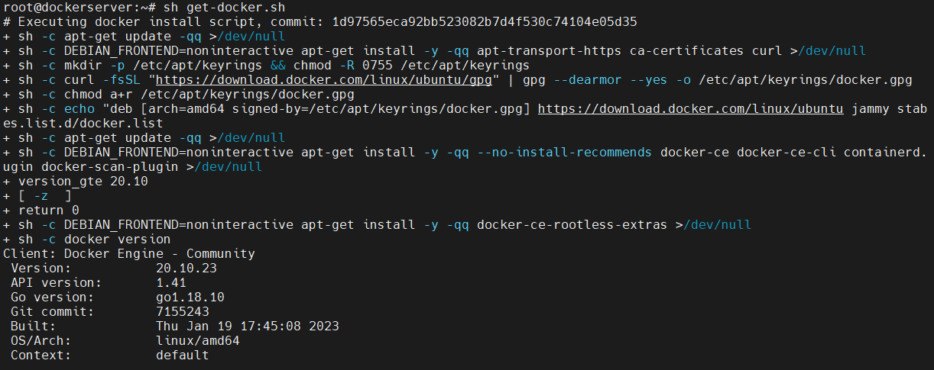
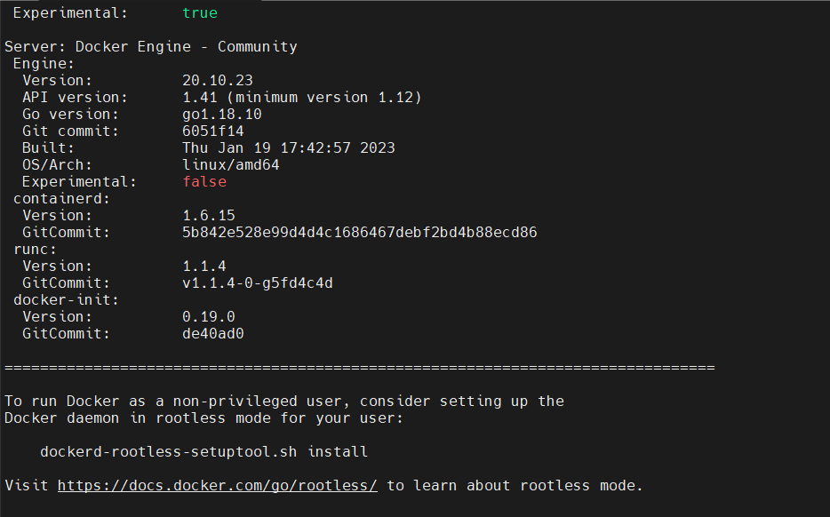
- The script installs only latest version packages. To install specified version, use other Docker Engine installation methods.
- To verify the installation & Version of Docker Engine run the command docker --version.
